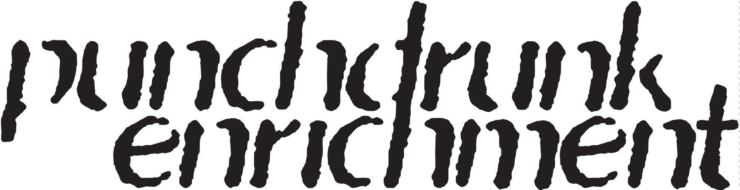

PUNCHDRUNK ENRICHMENT CASTING CALL

General Information

Should you need this information in an alternate format, please don't hesitate to give us a call at 020 7655 0940 and leave a message, or you can reach out via email at recruitment@punchdrunkenrichment.org.uk.

Punchdrunk Enrichment is looking for four performers for their new immersive production, aimed at families with children aged 6 to 11. The production will be part of the official opening of their brand new venue in Wembley Park.

At its heart, this production explores themes of storytelling, the power of family bonds, and the strength of community.

Key Dates

Interested candidates must be available for the following dates:

Auditions: 9th - 10th May 2024
Rehearsals: Monday, 20th May - Friday 7th June
Technical rehearsals: 10th to 12th June
Previews/Press: 13th and 14th June
Performance schedule:
Weekends only from 15th/16th June until 20th/21st July inclusive.
Thursday 25th to Sunday 28th July.
6 days per week from Tuesday 6th August to Sunday 1st September.
There will be 6 x 45 minute performances per day.

Character Breakdown

We are looking for four performers for two roles. Each actor will share their role across the week with another performer on rotation.

Female Character

- Playing Age: 30 to 35 years old.
- Heritage: Nigerian and West Indian.
- Character Traits: Resilient, adaptable, and persevering, with an unwavering work ethic.
- Skills Required: Competent singing abilities alongside a noteworthy level of physical agility. The role demands a performer who can embody passion and resilience through both vocal and physical expression.

Male Character

- Playing Age: 55 to 60 years old.
- Character Traits: Tender, kind, reserved, gullible, curious and sensitive.
- Skills Required: Physical agility is essential as well as a basic vocal ability. While not a trained singer, the performer should be able to carry a tune comfortably, reflecting his gentle and helpful personality in his vocal delivery.

Both characters are pivotal in leading the audience through an immersive journey, crafting their own heroic narratives. We're looking for actors who can resonate with the characters' essence and backstory.

The Ideal candidates will have:

- Experience of non-proscenium arch theatre work
- Experience of working in interactive performances with the ability to be adaptable and reactive to audiences
- Experience performing with young audiences.
- Strong facilitation experience.
- A base in London or able to commute to Brent.

Desirable
- Local knowledge, understanding or experience of the local area in Wembley Park, Brent.

Terms

Payment for performances in June and July will be based on a daily rate which is above ITC minimums (breakdown of ITC rates of pay, day rates, overtime details, holiday pay calculations etc included at offer stage). Whilst this position requires weekend availability, we are offering flexibility in scheduling, provided it aligns with the schedules of other actors sharing the same role.

From 25th July to the end of the contract, payment will be a weekly wage, above ITC minimums. Actors will be scheduled to perform a minimum of three days per week (out of 6 days) with the remaining days on an on-call basis. A full week's salary will still be paid even if they are not called for more than 3 days.

Our performance schedule is busy, with six 45 minute performances per day.

Due to the nature of the role, all performers will require a DBS check as part of the contracting process. If you have any issues or questions relating to DBS, please email recruitment@punchdrunkenrichment.org.uk with the heading ‘DBS enquiry - Wembley Auditions.’

Audition details and requirements

Auditions are scheduled at our home in Wembley Park.

Performers who are shortlisted for an audition will be given the opportunity to specify any access needs so that appropriate arrangements can be made.

The audition will be conducted in a workshop format at our accessible venue in Brent, London. Workshops are scheduled from 10am to 6pm on any of those days. We will confirm the exact timings with candidates who are invited to attend.

Disclaimer

Punchdrunk Enrichment is a committed equal opportunities employer. We are committed to ensuring that our workplace is free from unlawful or unfair discrimination on the grounds of age, disability, gender identity or gender expression, race, ethnicity, religion or belief, sex, sexual orientation, marital or civil partnership status, disability or pregnancy.

Your application and any associated personal information will be stored and processed in accordance with our Privacy Policy and destroyed after six months. We will keep your equal opportunities form for a period of six months, after which point the data will be anonymised and aggregated for monitoring purposes. If you are employed by us, the information you supply will be kept securely and will form part of your employment record.

HOW TO APPLY
How to Apply: Send an email to enrose@punchdrunkenrichment.org.uk

Use the subject line: ‘WEMBLEY AUDITIONS - [FEMALE/MALE] character application’. Include the following details:

- Full Name
- Desired Character
- Playing Age
- Mobile Number
- Email Address
- Your spotlight/mandy/Casting Callback/IMDB profile. Just one is enough.

Selection Process: If your application is successful, we will contact you to arrange an audition.

About Punchdrunk Enrichment

Punchdrunk Enrichment creates transformational theatrical experiences for education, community, and family audiences. We devise immersive productions and projects that have a powerful impact by placing people at the heart of an unforgettable journey. Through our adventurous, high-quality approach to storytelling we champion the imagination.

Punchdrunk Enrichment was founded by Artistic Director Peter Higgin in 2008 to take the innovative practice of Punchdrunk into communities and schools. Founded by Felix Barrett, Punchdrunk are celebrated as pioneers of a new form of theatre in which roaming audiences experience epic storytelling inside sensory theatrical worlds.

Since its inception, Punchdrunk Enrichment has delivered a wide range of projects in a variety of settings. Today, Punchdrunk Enrichment is an independent charity dedicated to creating experiences for as wide an audience as possible.

In May 2023 we embarked on a three year residency in an unused industrial unit in Wembley Park, Brent which will deliver the first ever co-created immersive arts space, co-designed and built with local makers and borough residents. During this period, Punchdrunk Enrichment will also foster new work, offer community inspired immersive experiences for families, projects for primary schools and training opportunities for Brent-based young people and artists.

For more information please visit : www.punchdrunkenrichment.org.uk

